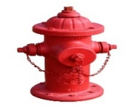 The Hydrant
JANUARY 2025 ISSUE “YOUR SOURCE FOR INFORMATION” ____________________________________
OUR MISSION
The mission of the Millington Fire Department is the protection of life and property from the adverse effects of fires, medical emergencies or exposure to dangerous conditions through fire suppression, rescue, disaster preparedness, fire prevention and community education.
The members of this department, working together, will provide a professional and caring environment that is fair, honest, and ethical and that treats all individuals with respect and dignity.
DEPARTMENT UPDATES______________________________________________________________________
Larry Dagen was sworn in as the new City Mayor on 1/1
Veterans Clinic broke ground on 1/7
City offices were closed on 1/10 due to snowy inclement weather
The department had their bi-annual staff meeting
Chief Graves attended the 100 Club Dinner and received a $1500 grant.
The department held an agility test at the training center for 3 applicants

______CALLS OF SERVICE________________TRAINING_________________________________________
Incident Type |  | Training type | Hours
Fire | 18 | EMS | 4.5
Overpressure Rupture | 0 | Driver/pump operations | 7.5
Rescue/EMS | 208 | Extrication | 0
Hazardous Conditions | 6 | Fire Suppression | 44.50
Service Calls | 11 | Haz-mat | 1
Good Intent | 23 | Safety | 5.5
False Alarm/Call | 19 | Special Operations | 3
Severe Weather/Disaster | 0 | Other | 0
Special | 0 | Supervisory | 2.5
Totals: | 285 | Totals: | 68.50

Community Involvement____________________________________________________________________
- Thank you to the Millington Primary school for inviting E332 out for Character Day.
- The Department installed 1 smoke detectors this month.
- Upon Request the Department is willing to give tours and provide fire prevention materials to individuals within the city limits of Millington. Please contact our administration office to schedule an appointment.
DATES TO REMEMBER:
The Admin Office will be closed the following dates
4/18-Good Friday
5/26-Memorial Day
7/4 Independence Day
9/1 Labor Day
1/11 Veterans Day

Quiz
1.What are the 4 categories of forcible entry tools?
2.What is the acceptable mounting height of a lockbox/Knoxbox?
3.What is the different tools called to remove deadbolt cylinders?

FACEBOOK
Millington Fire Department
Twitter
@MillingtonFD

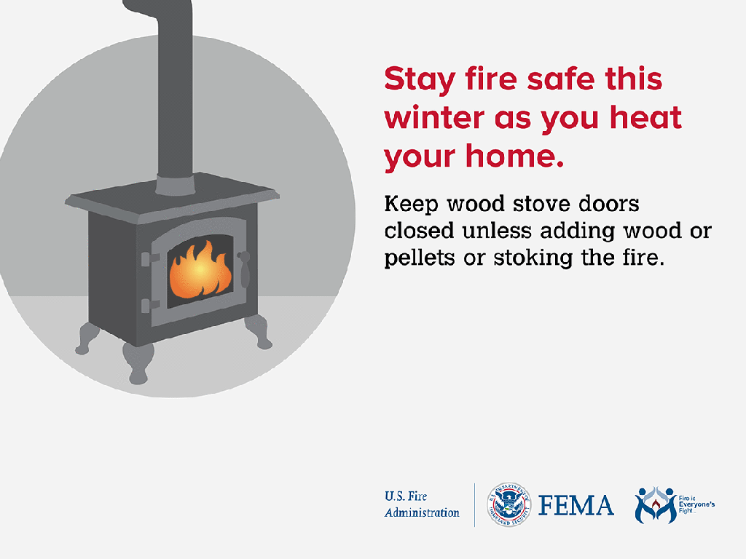

UPCOMING  FEBRUARY EMPLOYEE  ANNIVERSARIES | UPCOMING  FEBRUARY EMPLOYEE  BIRTHDAYS
Alton Pitts 12yrs  Alec Webber 2yrs | Rebecca Ervin 2/8  Jacob Reynolds 2/6  Alan Starnes 2/6  Quinn Hall 2/18

Answers to Quiz questions:
- Cutting
Prying
Push/Pull
Striking
- 4 to 7 feet from the finished surface
- K or A tool

